OS Assignment-13

Jeetu Mehra
U24AI032

1. Write a program to simulate segmentation using a static segment table and perform address translation.
#include <stdio.h>

#define MAX 10

// Segment Table Entry struct Segment {
int base; int limit;
};

int main() { struct Segment segTable[MAX];
int n, seg, offset;

// Input number of segments printf("Enter number of segments: "); scanf("%d", &n);

// Input segment table printf("\nEnter Base and Limit for each segment:\n");
for (int i = 0; i < n; i++) { printf("Segment %d:\n", i); printf("Base: "); scanf("%d", &segTable[i].base); printf("Limit: "); scanf("%d", &segTable[i].limit);
}

// Address translation loop while (1) { printf("\nEnter Segment number (-1 to exit): "); scanf("%d", &seg);

if (seg == -1) break;

printf("Enter Offset: "); scanf("%d", &offset);

// Validation if (seg >= n || seg < 0) { printf("Invalid Segment Number!\n"); continue;
}

if (offset < segTable[seg].limit) { int physical = segTable[seg].base + offset; printf("Physical Address = %d\n", physical);
} else {
printf("Segmentation Fault! Offset exceeds limit.\n");
}
}

return 0;
}
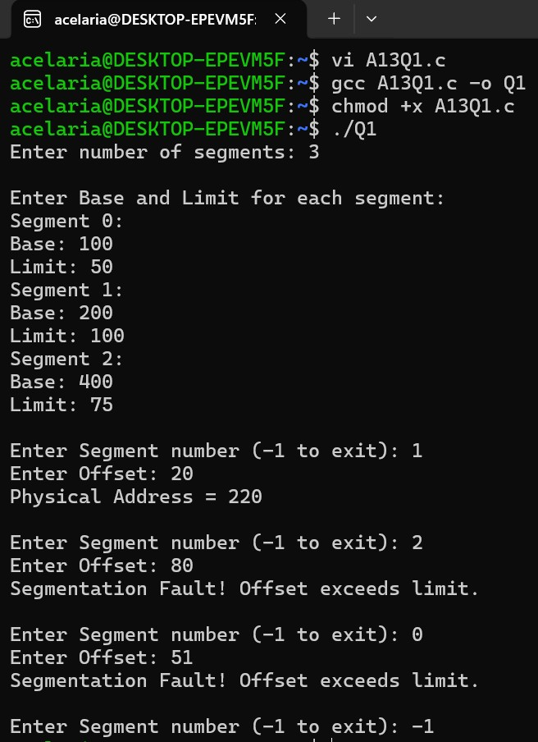
2. Create a simulation that takes a logical address (segment number + offset) and translates it to a physical address using a segment table.
#include <stdio.h>

#define MAX 10

struct Segment {
int base; int limit;
};

int main() { struct Segment segTable[MAX];
int n, seg, offset;

// Input number of segments printf("Enter number of segments: "); scanf("%d", &n);

// Input segment table printf("\nEnter Base and Limit for each segment:\n");
for (int i = 0; i < n; i++) { printf("Segment %d -> Base: ", i); scanf("%d", &segTable[i].base); printf("Segment %d -> Limit: ", i); scanf("%d", &segTable[i].limit);
}

// Input logical address
printf("\nEnter Segment number: "); scanf("%d", &seg);

printf("Enter Offset: "); scanf("%d", &offset);

// Address translation if (seg < 0 || seg >= n) { printf("Invalid Segment Number!\n");
}
else if (offset >= segTable[seg].limit) { printf("Segmentation Fault! Offset exceeds limit.\n");
} else { int physical = segTable[seg].base + offset; printf("Physical Address = %d\n", physical);
}

return 0;
}
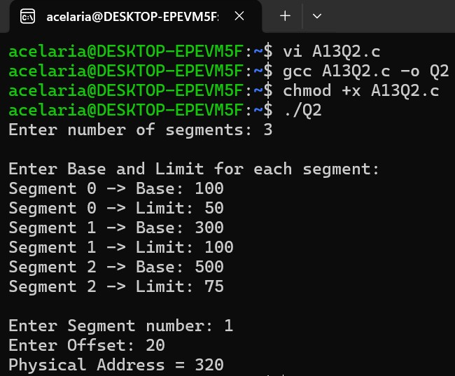
3. Implement a model where each process is divided into segments (code, data, stack), and manage memory allocation and deallocation for each.
#include <stdio.h>

#define MAX_PROCESSES 10
#define MEMORY_SIZE 1024

// Segment structure struct Segment {
int base; int limit; int allocated; // 1 = allocated, 0 = free
};

// Process structure (3 segments) struct Process { struct Segment code; struct Segment data; struct Segment stack; int active;
};

struct Process processes[MAX_PROCESSES]; int memory[MEMORY_SIZE];
int free_ptr = 0;

// Allocate memory block int allocate_block(int size) { if (free_ptr + size > MEMORY_SIZE) { return -1; // Not enough memory
}
int base = free_ptr; free_ptr += size; return base;
}

// Allocate process segments void allocate_process(int pid) {
int c, d, s;

printf("Enter Code, Data, Stack sizes for Process %d: ", pid); scanf("%d %d %d", &c, &d, &s);

int base;

// Code segment base = allocate_block(c); if (base == -1) { printf("Memory allocation failed!\n");
return;
}
processes[pid].code.base = base; processes[pid].code.limit = c; processes[pid].code.allocated = 1;

// Data segment base = allocate_block(d); if (base == -1) { printf("Memory allocation failed!\n");
return;
}
processes[pid].data.base = base; processes[pid].data.limit = d; processes[pid].data.allocated = 1;

// Stack segment base = allocate_block(s); if (base == -1) { printf("Memory allocation failed!\n"); return;
}
processes[pid].stack.base = base; processes[pid].stack.limit = s; processes[pid].stack.allocated = 1;

processes[pid].active = 1;

printf("Process %d allocated successfully.\n", pid);
}

// Deallocate process void deallocate_process(int pid) { if (!processes[pid].active) { printf("Process not active!\n"); return;
}

processes[pid].code.allocated = 0; processes[pid].data.allocated = 0; processes[pid].stack.allocated = 0; processes[pid].active = 0;

printf("Process %d deallocated.\n", pid);
}

// Display memory state void display() { printf("\nProcess Table:\n"); printf("PID\tCode(Base,Limit)\tData(Base,Limit)\tStack(Base,Limit)\n");

for (int i = 0; i < MAX_PROCESSES; i++) { if (processes[i].active) { printf("%d\t(%d,%d)\t\t(%d,%d)\t\t(%d,%d)\n",
i,
processes[i].code.base, processes[i].code.limit, processes[i].data.base, processes[i].data.limit, processes[i].stack.base, processes[i].stack.limit);
}
}
}

int main() { int choice, pid = 0;

while (1) { printf("\n1. Allocate Process"); printf("\n2. Deallocate Process"); printf("\n3. Display"); printf("\n4. Exit\n");

printf("Enter choice: "); scanf("%d", &choice);

switch (choice) { case 1:
if (pid >= MAX_PROCESSES) { printf("Max processes reached!\n"); } else { allocate_process(pid); pid++; } break;

case 2: { int p;
printf("Enter PID to deallocate: "); scanf("%d", &p); deallocate_process(p); break;
}

case 3: display(); break;

case 4: return 0;

default:
printf("Invalid choice!\n");
}
}
}
